

**________________________________________________________________________**

**IX610001 Programming 3**

**Lab Assignment 1 – Application**

**________________________________________________________________________**

Due date to be handed in: Week 8 - (2nd March)

Submission: Upload soft copy to Moodle

Demo: To Lecturer (Compulsory)

Contact Lecturer: Tariq Khan

Weighting/Contribution: 35% to final marks

**________________________________________________________________________**

# UML Diagram

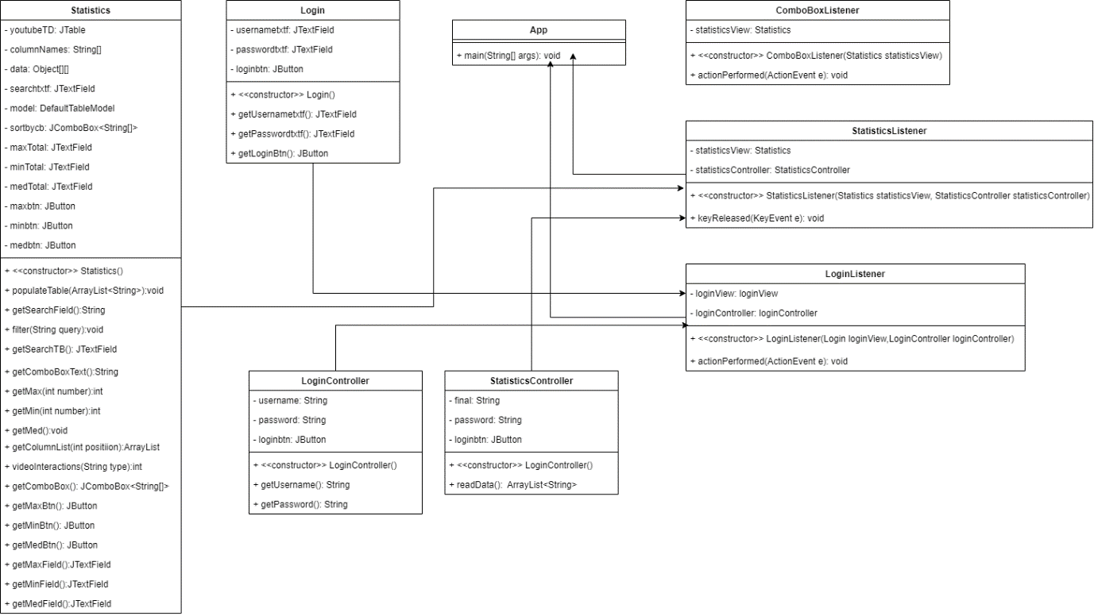

## App Class

The main app class is in charge of initiating the main application and the login screen by passing instantiating login class and the passing down the needed arguments to this method.

## Combo Box Listener Class

The combo box listener is in charge of creating the event for the comb box listener and other related button that are needed, these are hooked to an action listener that runs a different method depending where the action was executed.

## Statistics Listeners Class

The Statistics Listener hooks an event that is executed when a key release event is executed and receives 1 argument which is the statistics view, this is done in order to be able to use the statistics methods on the specific event which is executed.

## Login Listener Class

The Login Listener hooks an event that is executed on a button click, and receives 2 arguments these are the login view and the login controller which allows the communication view and the controller

## Statistics Controller Class

The statistics controller is in charge of reading the data from the CSV file and this data is then stored into a 2-dimensional array for later usage.

## Login Controller Class

The Login Controller class is used to store the username and password in order to login

## Login View Class

The login view class has the methods that read all the items from the view

## Statistics View Class

The statistics view class has most of the methods that allow the communication from the view to the hooks and tables in order to fill information sort and get maximum, minimums and medians.